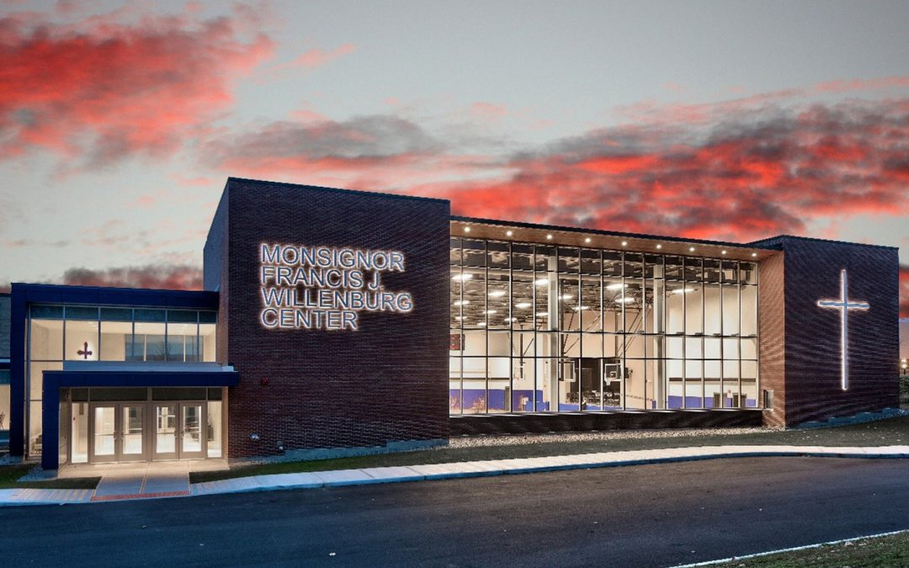

MINIMUM CAPACITY :-

The Minumum intake capacity

of students is between 300-620

children

LIBRARY :-

The Libarary is Available.

CANTEEN:-

The Canteen Facility is Available.

BOARDING :-

No availablility of boarding.

SPORTS :-

There are different categories

sports available.

Girls Volleyball

Boys Volleyball

Football

|  |  |  |
| --- | --- | --- |
| NOTRE DAME SCHOOL  YONKERS - SCHOOL |  |  |
|  |  |  |
| School Detail :- At Notre Dame, we want to ensure that every student has the opportunity and the confidence to pursue their academic and extracurricular interests. We are thrilled to officially launch four new signature programs to students, including technology, engineering, and design ( T/ E / D ), video production, sports medicine, and leadership.  We encourage our students to develop a thirst for knowledge and truth, and we instill in them the determination to strive. |  |